EMBEDDED SYSTEM WITH IOT
EXPERIMENT NO. 7

IOT-BASED FIRE ALARM SYSTEM

Name: Raphael S. Nano

Course/Section: CPE162P / C1

Date of Performance: April 9-12, 2024
Date of Submission: April 12, 2024

Ma'am Cyrel Manlises
Instructor

DISCUSSION

Fire alarm systems are crucial in constructing a building, whatever purpose the building may have. These systems help mitigate the quick spread of fire in a certain area. With the addition of an accurate detection system with several sensors and the like, the prevention of the fire itself becomes more efficient. Moreover, with the implementation of IoT with fire alarm systems, the notification of fire detections and the area in which it occurred can be shown to and seen by the user remotely. Therefore, with the use of an ESP8266 as the controller, an IoT-based Fire Alarm System was developed using a flame sensor, a passive buzzer, and LEDs.

The objectives for experiment 7 are the following:
1. To demonstrate how an IoT-based Fire Alarm System works in a 4-storey building.
2. To be able apply what you have learned in logic circuits and switching theory, microprocessors, CPE160P, and CPE161P.
3. To be able to apply embedded system with IoT using Arduino kit
4. To be able to use ThingSpeak for the data collection and analysis.

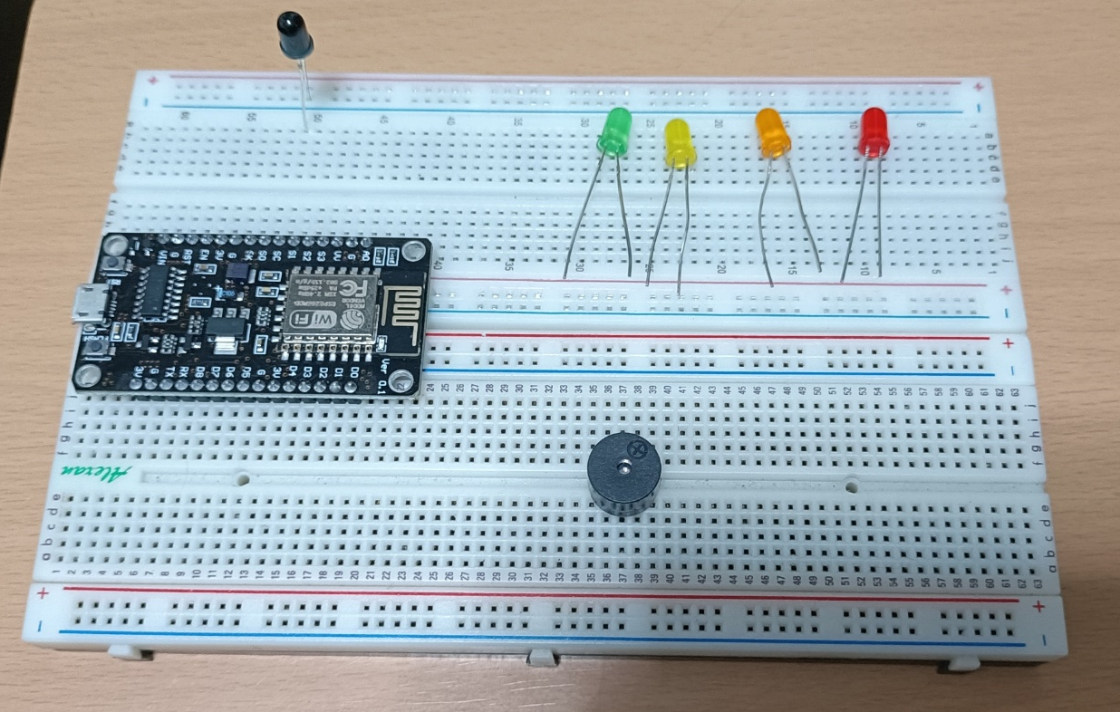
In order to construct the IoT-based Fire Alarm System, the flame sensor and the passive buzzer are the main components. LEDs were added for floor indicators and the ESP8266 is the controller of the system.

Figure 1. Main Components of the Experiment
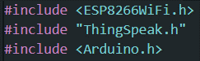
For the embedded system to connect to ThingSpeak, the libraries shown below were included.

Figure 2. External Libraries Included

Experiment 7 aims to create a system where it will sense the fire using the flame sensor and activate the buzzer correspondingly. LEDs were added in order to have a floor indicator, and ThingSpeak was utilized in order to show if the fire alarm in a certain floor was turned on.
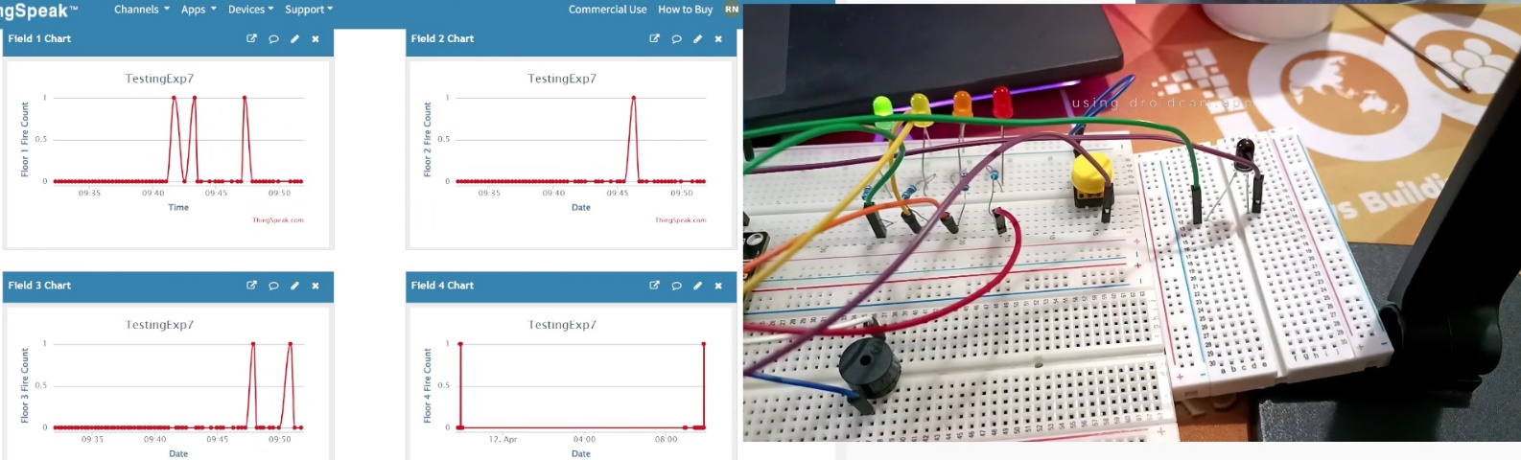

Figure 3. Sample Output of Experiment 7

There are three main functions of the system: one for the flame sensor, one for the passive buzzer, and one for the LEDs.
The normal reading for the flame sensor is any integer below 100. Hence, the threshold for the sensor was set to 500. If the value using analogRead() was more than 500, the passive buzzer is then activated.
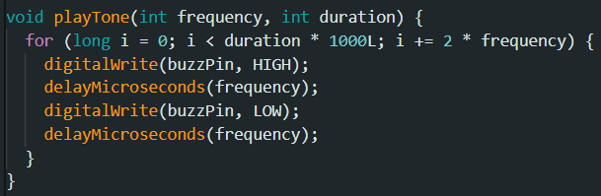
The passive buzzer is activated using a separate playTone() function, which uses frequency and duration.

Figure 4. Function for Passive Buzzer

For the LEDs, a button was utilized to switch from one to four, then back to one. Green LED is for Floor 1, Yellow for Floor 2, Orange for Floor 3, and Red for Floor 4.

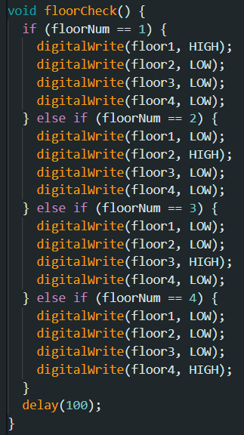

Figure 5. Function for LED outputs
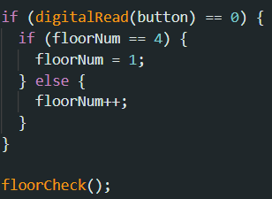

Figure 6. Button Function

The last feature of the system is the displaying of output in the ThingSpeak. Every 15 seconds, the status of each floor (meaning if there is a fire present at the moment) would be displayed as one (there is a fire) or zero (no fire).
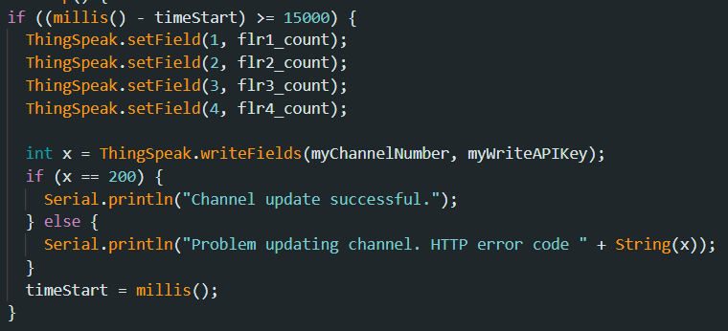

Figure 7. LCD Functions
RESULTS
The IoT-based Fire Alarm System was tested for four conditions, particularly the four floors of the building. The system successfully alarms every time a fire or flame is detected near it. Moreover, ThingSpeak continuously updates the status of the alarm every 15 seconds.
As seen in the graphs, each of the floor experienced the fire alarm being activated. The values state that Floor 1 triggered the alarm 4 times, which is the highest among the floors, and two of which are close to one another. Floor 2, on the other hand, was only triggered once. Floor 3 triggered the fire alarm 3 times. Lastly, Floor 4 triggered the fire alarm twice, however, both have a large gap between each other.
This suggests that Floor 1 was the most prone to fire accidents, however it was not quickly mitigated because there is a continuous fire alarm detected, while Floor 2 has the strongest countermeasures against fire since the fire only occurred once.
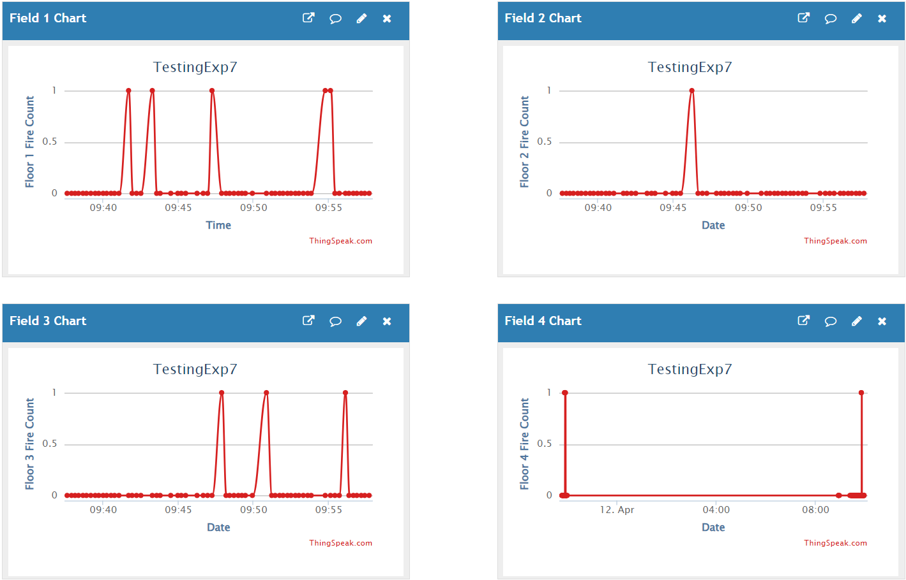

Figure 8. Final ThingSpeak Output
CONCLUSION
Ultimately, the IoT-based Fire Alarm System works in a 4-storey building with the following operations: (1) the flame sensor detects fire with threshold of 500, (2) the passive buzzer alarms thrice after detection, (3) an LED shows what floor is currently being detected, and (4) the button is used to switch among floors. To apply the past lessons, the proper connection of wires, application of the codes, and the implementation of IoT were done, which were learned during CPE160P and CPE161P. The ThingSpeak was synchronized successfully with the ESP8266, wherein it outputs every 15 seconds, achieving the fourth objective. Therefore, with the creation of the IoT-based Fire Alarm System, an embedded systems with IoT was created using the flame sensor, passive buzzer, LEDs, a button, and the ESP8266.

